**RUBELLITE**

**T. E. Information Technology**

By

**Group No. – 07**

**CHANDNI PATEL 15**

**HETAL PORIYA 20**

**Ms. Sonali Vaidya**

Assistant Professor



Department of Information Technology

St. Francis Institute of Technology

(Engineering College)

University of Mumbai

2019-2020

**Mini Project Approval Certificate**

This Mini-project proposal Rubellite by Ms. Chandni Patel, Ms. Hetal Poriya is approved and they must complete the mini project in all respects by 28 August 2019.

Mini Project Review Panel

1.

2.

3.

Date:

Place:

**Index**

|  |  |  |
| --- | --- | --- |
| **Sr. No.** | **Content** | **Page No.** |
|  | Weekly Activity Schedule |  |
|  | Project Report – Web design proposal |  |
| 3. | Project Report – Requirement Analysis |  |
| 4. | Output |  |
| 5. | Conclusion |  |
| 6. | Remarks |  |
| 7. | Work Contribution |  |

**Signature:**

**Ms. Sonali Vaidya**

**(Internal Guide)**

**Weekly Activity**

|  |  |  |  |  |  |  |
| --- | --- | --- | --- | --- | --- | --- |
| **Sr. No.** | **Activity** | **Date of performance** | **Date of Submission** | **Status** | **Remarks** | **Sign** |
| **1** | Formulate a web design proposal containing requirement analysis and design a skeleton/prototype for website | 10/07/2019 |  |  |  |  |
| **2** | Create a webpage using HTML and different types of CSS | 17/07/2019 |  |  |  |  |
| **3** | Perform form validation using JavaScript | 24/07/2019 |  |  |  |  |
| **4** | Design a Web Layout Using RWD Framework demonstrating various HTML5 features | 31/07/2019 |  |  |  |  |
| **5** | Demonstrate CSS3 transition, transformation, animation, aesthetics and responsive form in your website. | 07/08/2019 |  |  |  |  |
| **6** | Mid Term Project Evaluation | 21/08/2019 |  |  |  |  |

**Signature:**

**Ms. Sonali Vaidya**

**(Subject Teacher/Internal Guide)**

|  |  |  |
| --- | --- | --- |
| **PROJECT REPORT** | | |
| **Section 1 -** | | **Web Design Proposal** |
| **1.** | **Application Title -** | **RUBELLITE** |
| **2.** | **Overview -** | Our website Rubellite will provide unique range of imitation jewellery for every occasion and which will be pocket friendly for the users.  One can shop their ready-to-wear designer collection to suit one’s personal style. |
| **3.** | **Need of the Application-** | Teenagers get easily embrace with fashion, so in day to day life if we want to dress up in a less budgeted way this is the most reliable site. |
| **4.** | **Objective -** | * Variety * Reasonable * User friendly * Wide variety for every occasion * For a complete look based * Delivery |
| **5.** | **Problem statement-** | Rubellite is an online marketplace of curated fine jewellery. It offers a wide range of jewellery products. It is a leading destination for online shopping. It offers some of the best prices and hassle free experience with various paying options. |

|  |  |  |
| --- | --- | --- |
| **Section 2 -** | | **Requirement Analysis** |
| **1.** | **Target Audience -** | Our main target audience are the teenagers. |
| **2.** | **Features Required -** | Searching  Login  Sign Up  Cart  Category etc. |
| **3.** | **Software and Hardware requirements -** | 1. **Software requirements –**  |  |  |  | | --- | --- | --- | | 1. | Adobe XD | 20.2.12.1 | | 2. | Operating System | Windows Operating System | | 3. | Notepad++ | Yes | | 4. | Web Browser (google chrome ) | Yes |  1. **Hardware requirements –**  |  |  |  | | --- | --- | --- | | 1. | RAM | 4GB, 8GB | | 2. | Intel processor | i5, i7 and so on | | 3. | CPU | CPU Intel® Core™ i5-7200U CPU@2.50Ghz | | 4. | Internet connection | Yes | |
| **4.** | **Sites referred -** | * [**https://www.voylla.com/**](https://www.voylla.com/) * [**https://www.cilory.com/64-jewellery**](https://www.cilory.com/64-jewellery) * [**https://www.mirraw.com/store/jewellery**](https://www.mirraw.com/store/jewellery) |

Prototype:

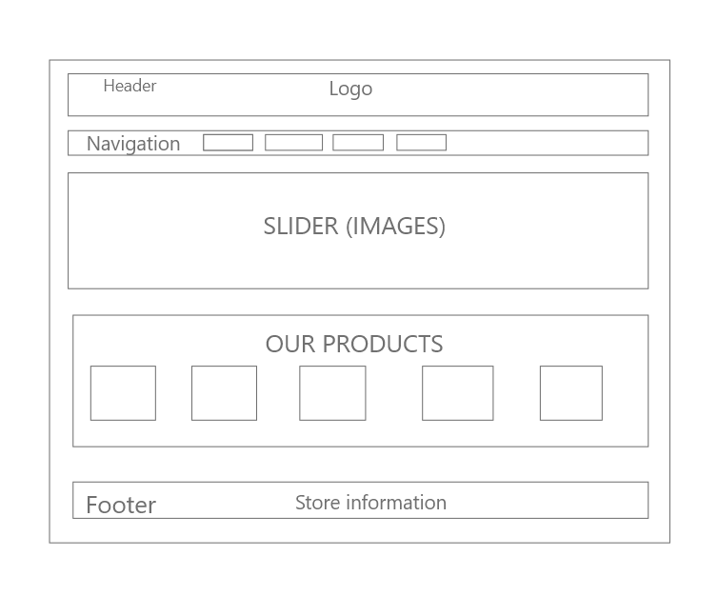

**Fig 1: Home Page**

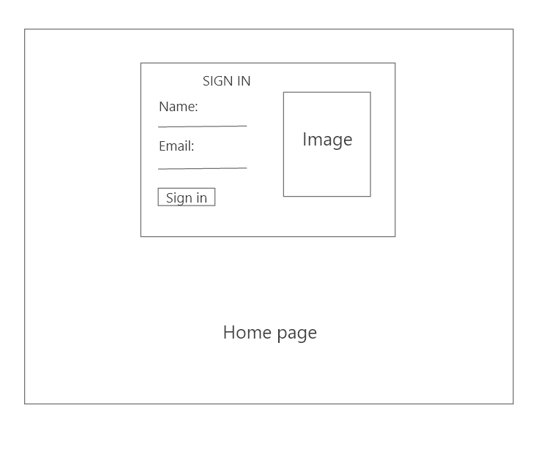

**Fig 2: Sign In page**

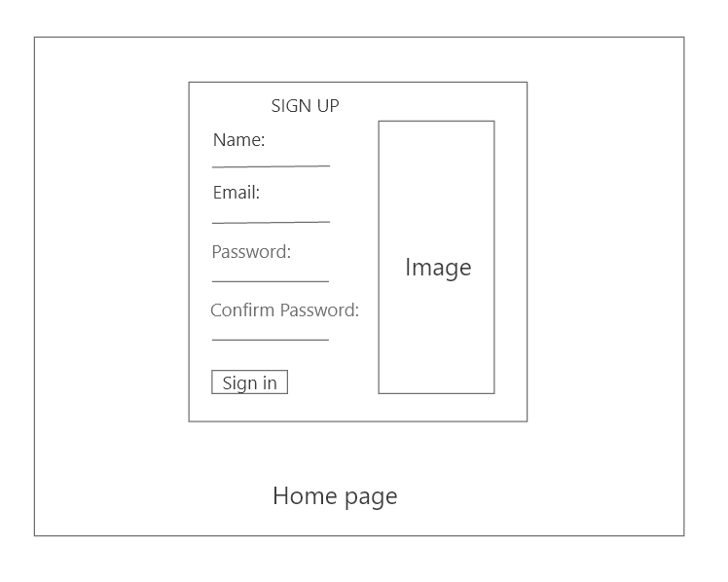

**Fig 3: Sign Up page**

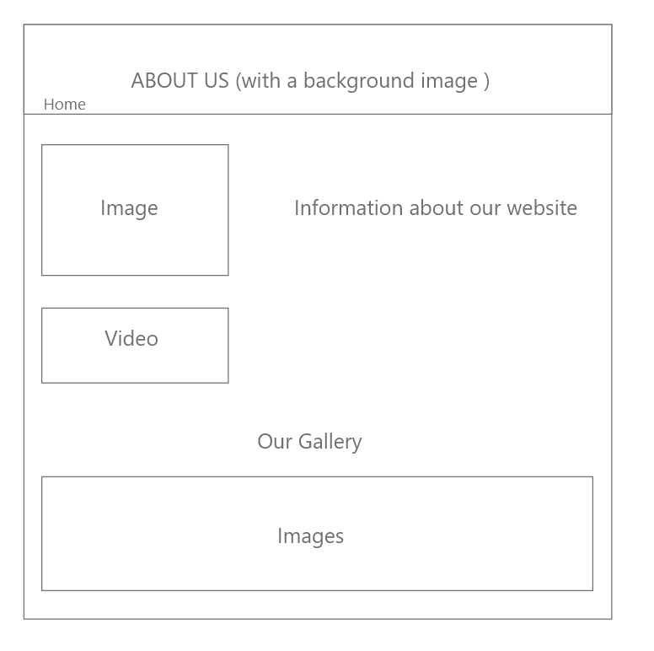

**Fig 4: About Us page**

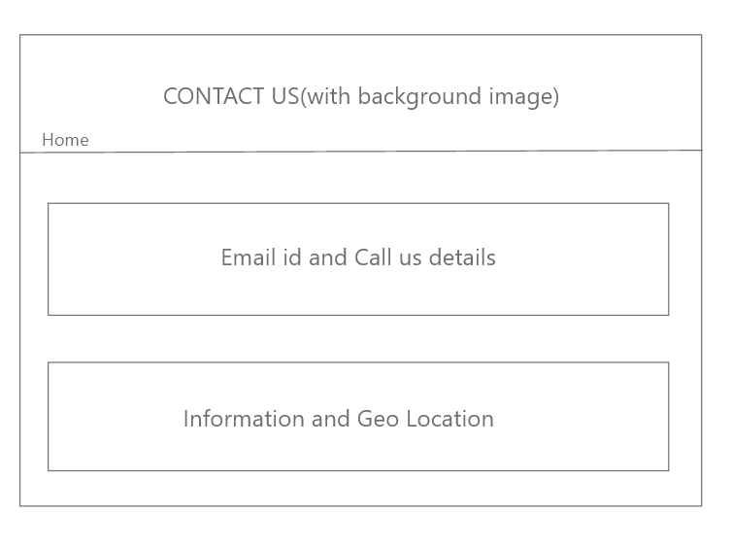 **Fig 5: Contact Us page**

Output:

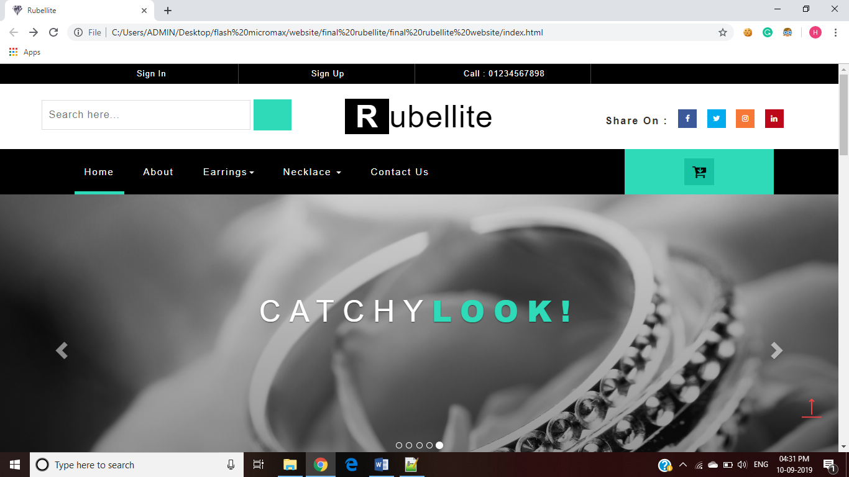

**Fig 6: Home page**

|  |  |  |
| --- | --- | --- |
| **Sr No.** | **Features Used** | **Technology Used** |
| 1 | Logo | CSS |
| 2 | Navigation Bar | Html5 |
| 3 | Header | Html |
| 4 | Slider | CSS3 Carousel Slideshow |
| 5 | Button | CSS3 Transformation |
| 6 | Responsive | View Port + Fluid Page |
| 7 | Search | Html + CSS |
| 8 | Share On | CSS3 Transformation |
| 9 | Favicons | HTML |
| 10 | Footer | HTML |

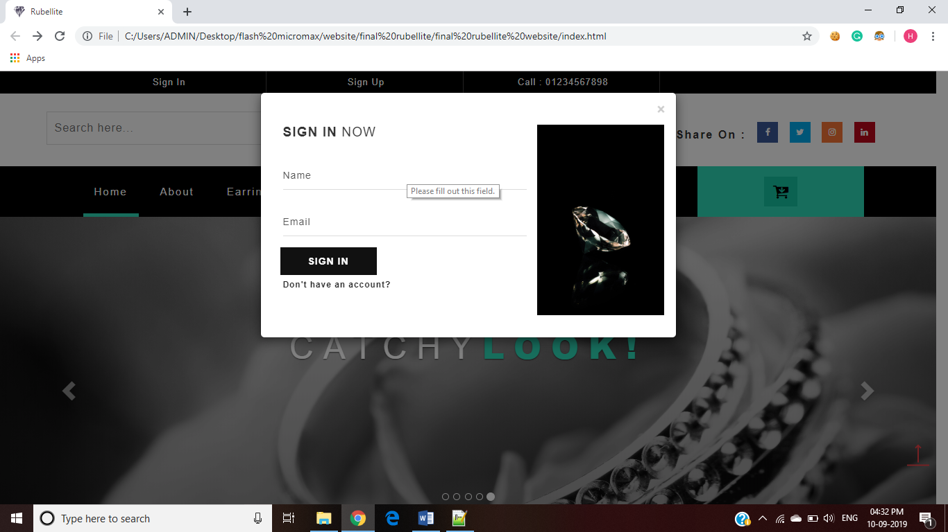

Fig 7: Sign in Page

|  |  |  |
| --- | --- | --- |
| Sr No. | Features Used | Technology Used |
| 1 | Modal Effect | CSS3 + html5 |
| 2 | Responsive | View Port + Media Query |
| 3 | Button | CSS3 Transformation |
| 4 | Form | Html 5 + CSS 3 |
| 5 | Form Validation | Html5 |
| 6 | Font | CSS3 |

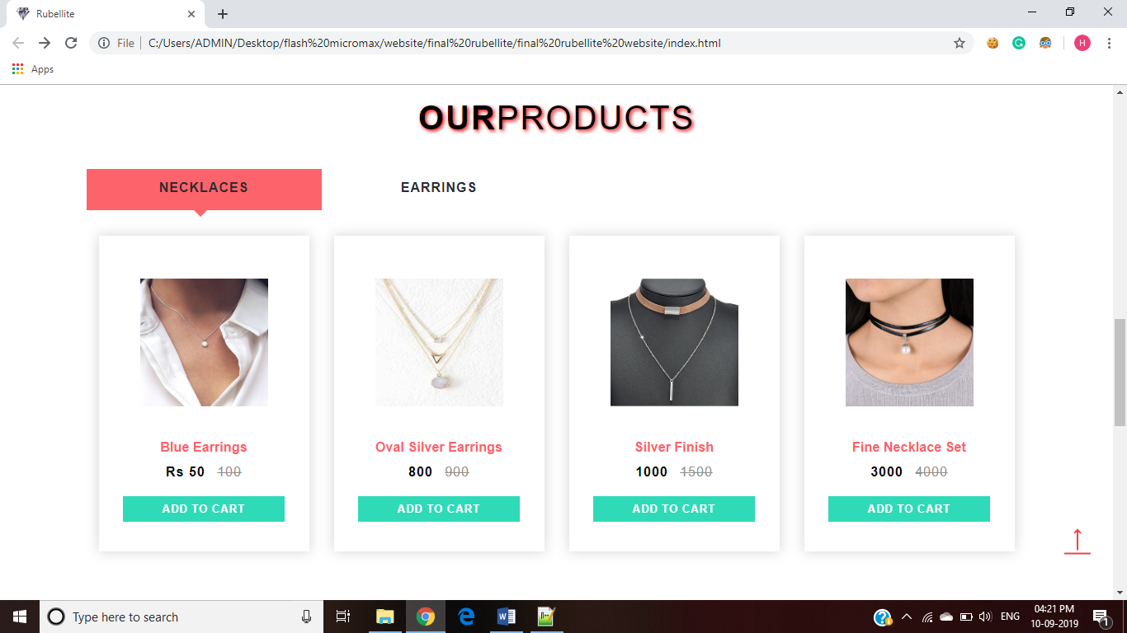

Fig 8: Product Page

|  |  |  |
| --- | --- | --- |
| Sr No. | Features Used | Technology Used |
| 1 | Text Shadow | CSS3 + html5 |
| 2 | Responsive | Media Query |
| 3 | Button | Html+ CSS |
| 4 | Tabs | HTML(list) |
| 5 | Box Shadow | CSS3 |
| 6 | Font | CSS3 |
| 7 | Up Arrow | HTML |

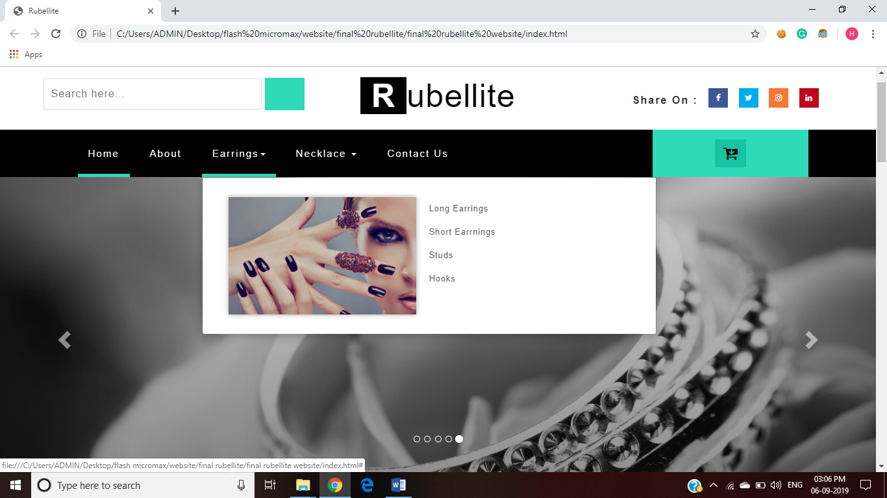

Fig 9:Navigation

|  |  |  |
| --- | --- | --- |
| Sr No. | Features Used | Technology Used |
| 1 | List | Html |
| 2 | Responsive | View Port + Media Query |
| 3 | Drop Down | CSS3 |
| 4 | Header | Html 5 |

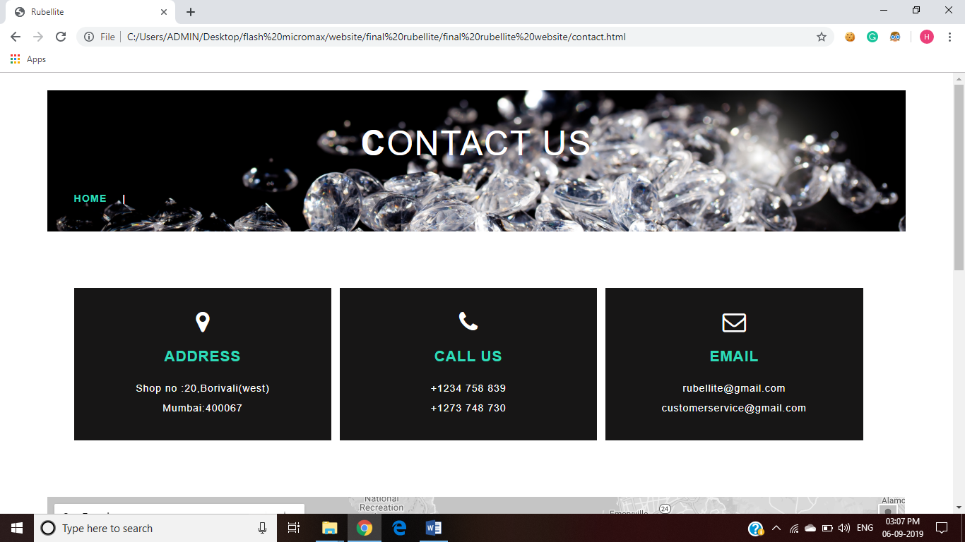

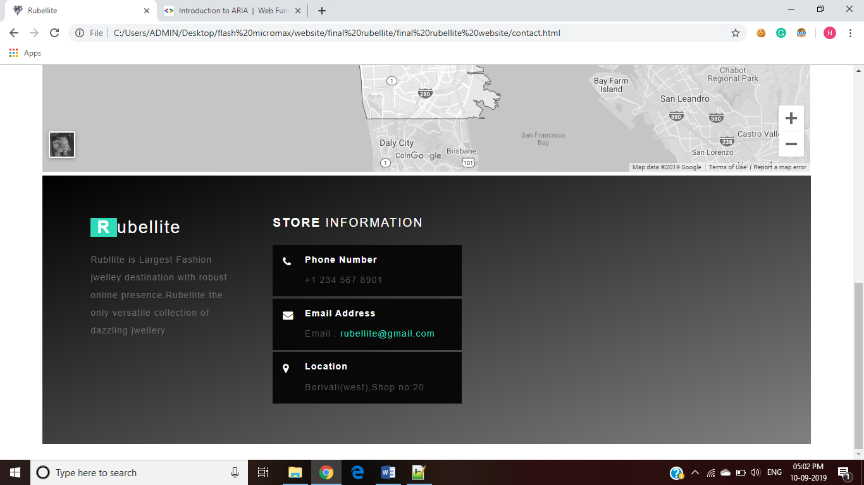

Fig 10: Contact Us page

|  |  |  |
| --- | --- | --- |
| Sr No. | Features Used | Technology Used |
| 1 | Geo location | Html5 maps |
| 3 | Form | Html 5 |
| 4 | Gradient | CSS |

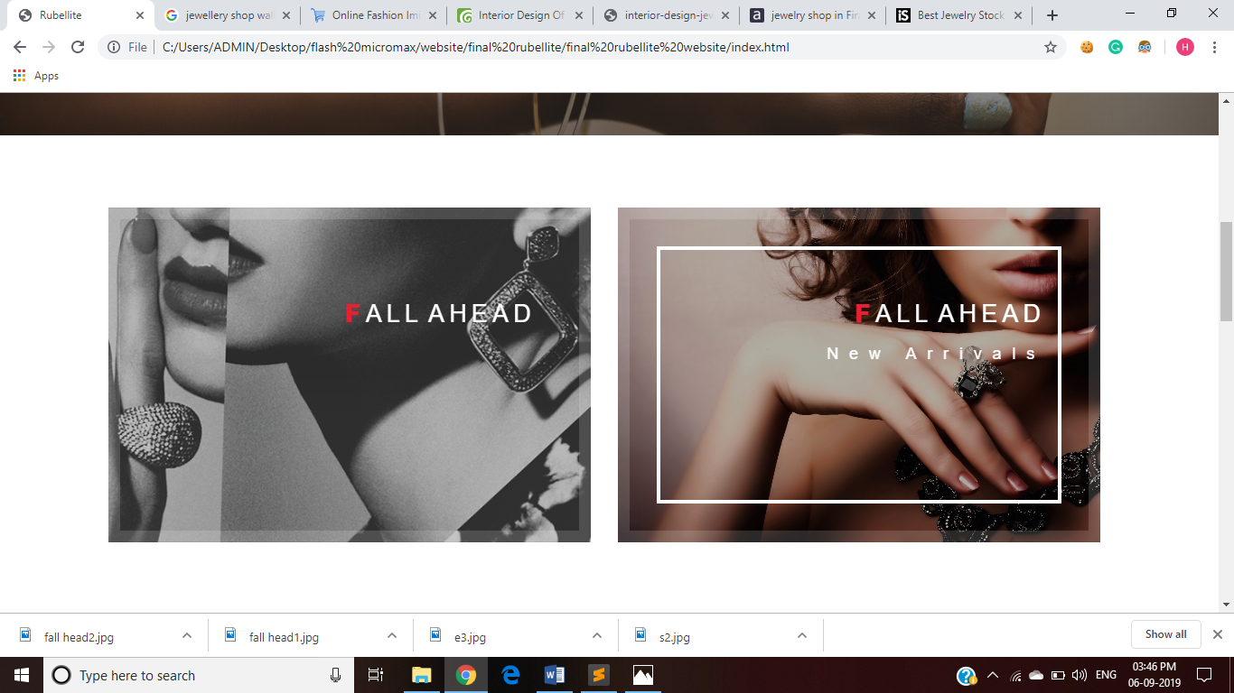

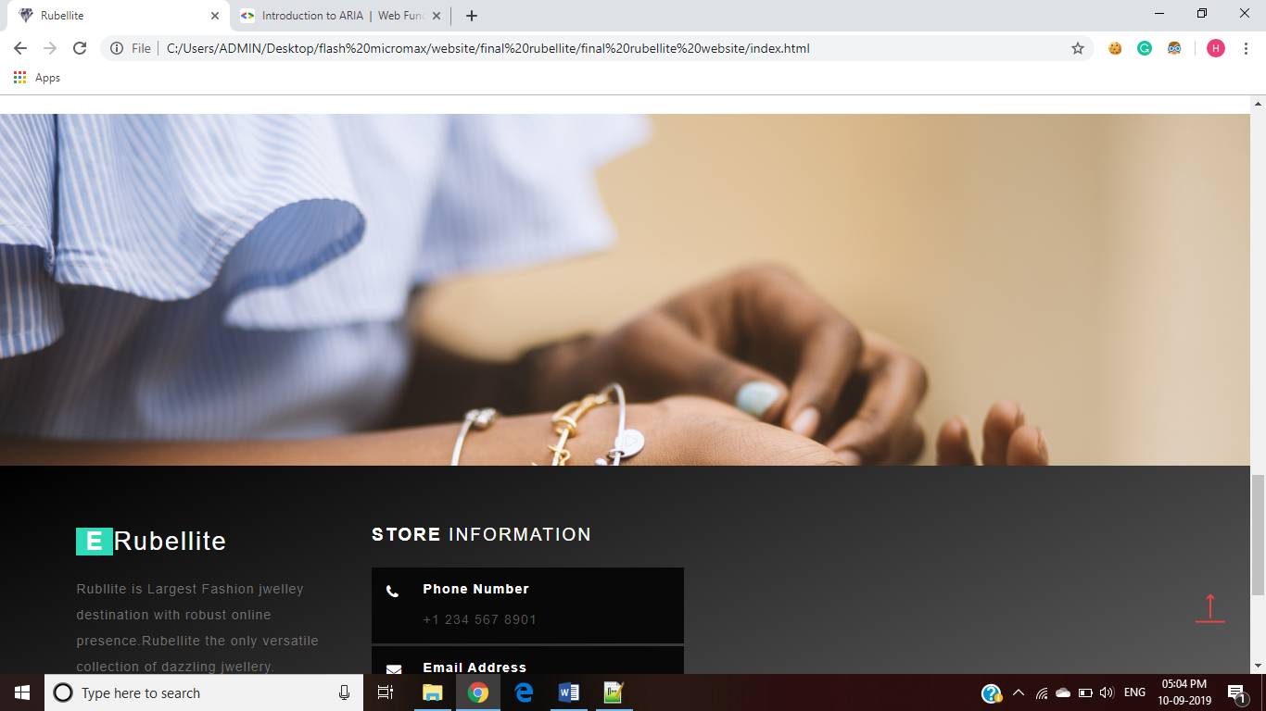

Fig 11: Fixed Background

|  |  |  |
| --- | --- | --- |
| Sr.NO | Features Used | Technology Used |
| 1 | Header + Footer | HTML5 |
| 2 | Animation(Image) | CSS3 |
| 3 | Text Animation | HTML5 |
| 4 | Fixed Background | CSS |

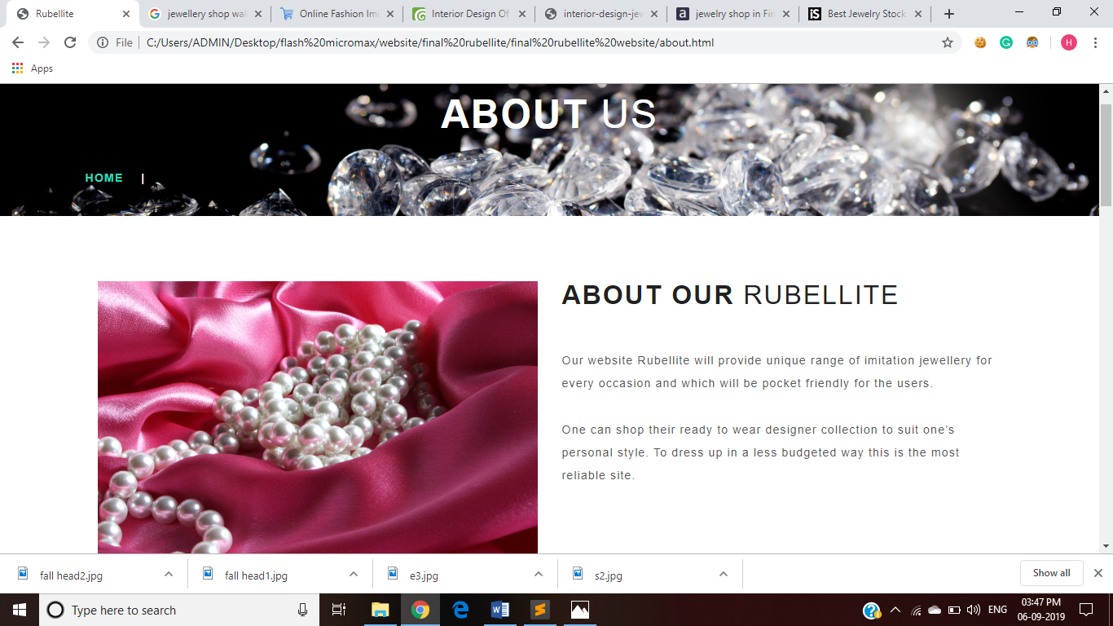

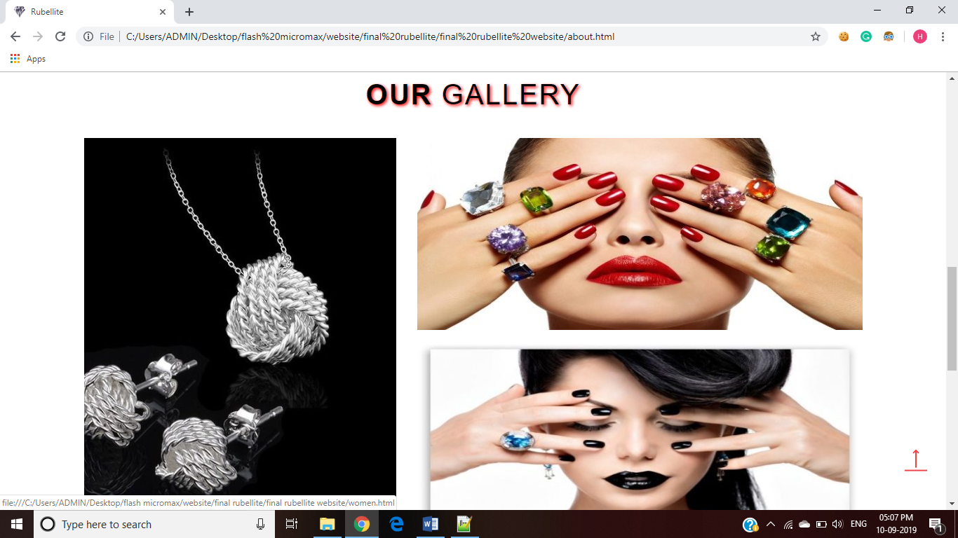

Fig 11: About Us page

|  |  |  |
| --- | --- | --- |
| Sr No. | Features Used | Technology Used |
| 1 | Section | HTML5 Semantic |
| 2 | Responsive | View Port + Media Query |
| 3 | Footer | HTML 5 |
| 5 | Video | HTML 5 |
| 6 | Text Shadow | CSS |

CONCLUSION:

Our Project RUBELLITE has been developed as per the requirement specification and convenience. It has been developed using HTML, HTML5, CSS and CSS3. The complete website is thoroughly developed from the Customer Point of View for easy access to our wide range of jewellery. RUBELLITE is online system, which enable customer to search the jewellery, buy jewellery. It also provides express delivery service. It makes the customer easy to get jewellery online instead of wasting a lot of time at the shop. This website is developed to achieve maximum efficiency in shopping online and to reduce the time taken to purchase jewellery item.

Design Proposal and output reports are presented in the report.